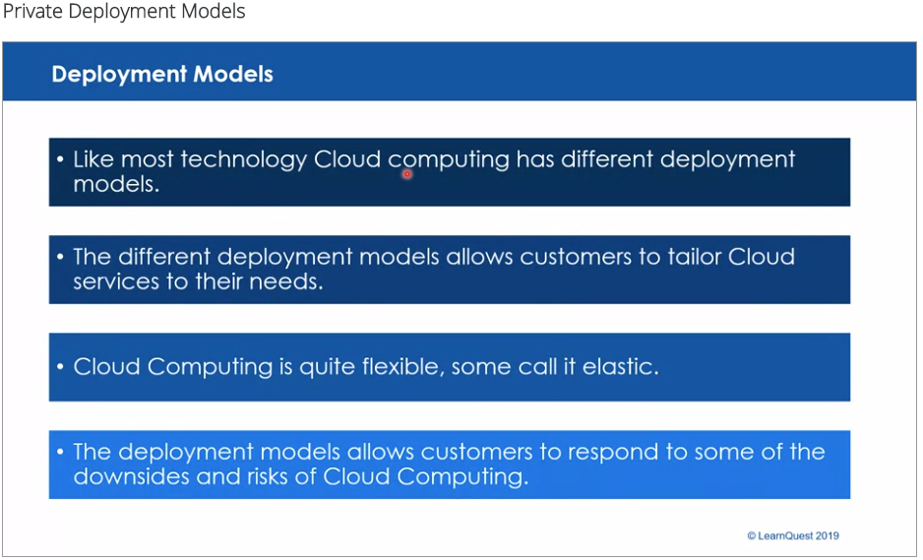

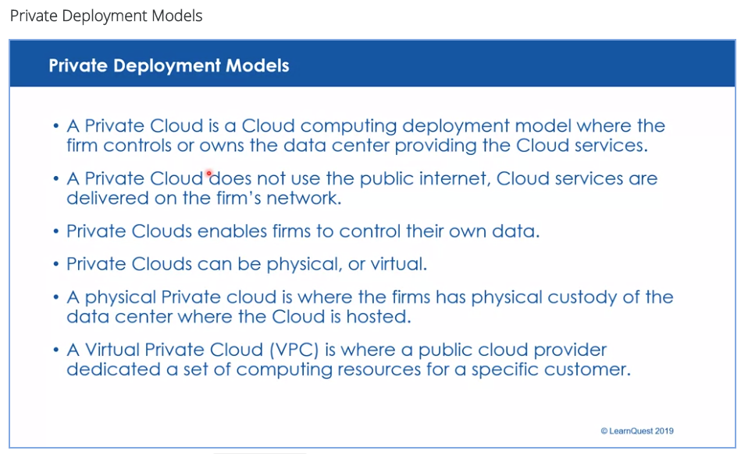

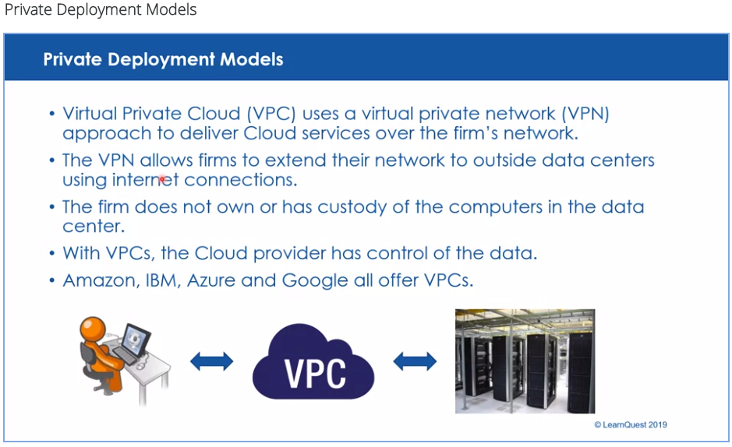

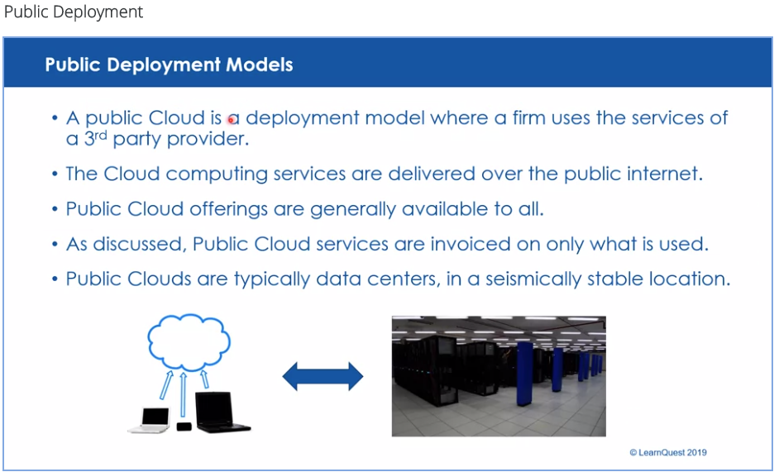

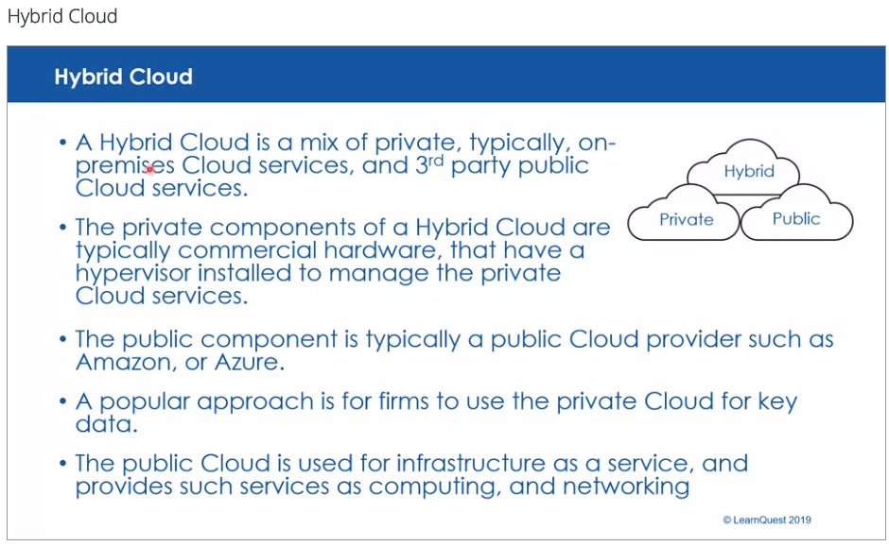

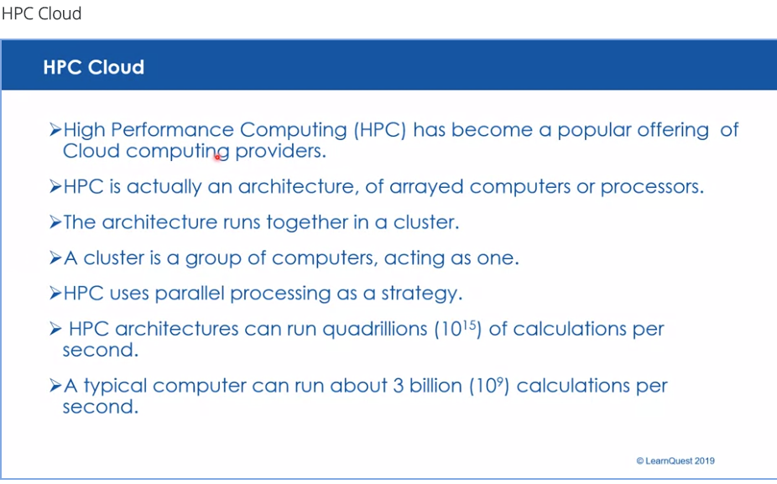

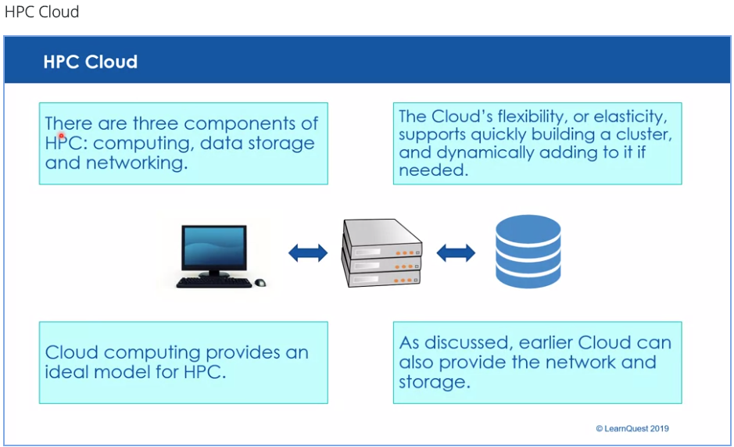

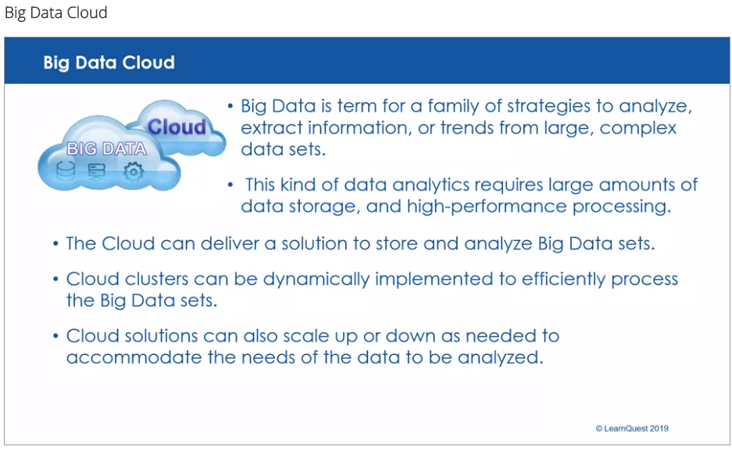

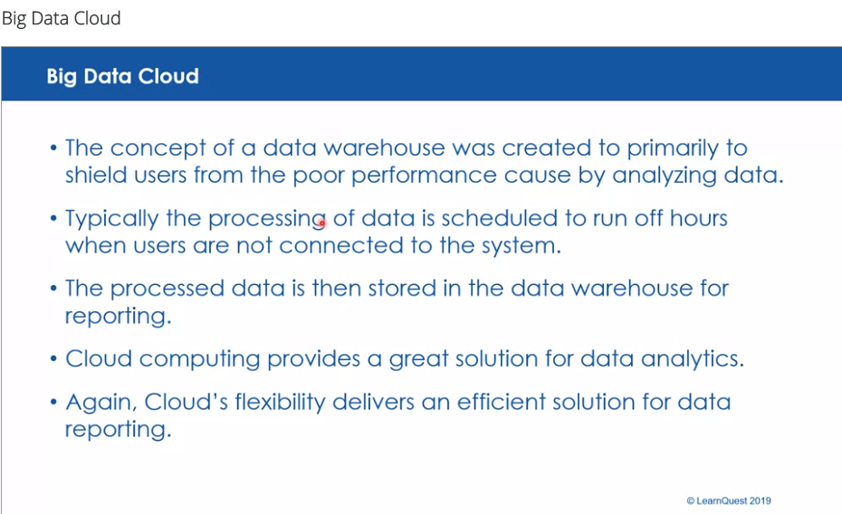

Deployment Models

The Private Cloud is Cloud computing services offered by an enterprise on its private internal network and only to select users instead of the general public. Also referred to as an internal or corporate cloud, private cloud computing gives businesses many of the benefits of Cloud computing such as: self-service, scalability, and elasticity. However, a private Cloud offered the enterprise control and customization of the data and hardware resources. The enterprise also has control over the computing infrastructure hosted on-premises. In addition, private clouds deliver a higher level of security and privacy through both company firewalls and internal hosting to ensure operations and sensitive data are not accessible to third-party providers. One disadvantage is that the enterprise's IT department is held responsible for the cost and accountability of managing the private cloud. So private clouds require the same staffing, management, and maintenance expenses as traditional data center ownership.

A [Virtual Private Cloud (VPC)](https://en.wikipedia.org/wiki/Virtual_private_cloud) is an on-demand configurable pool of shared computing resources allocated by a public Cloud provider, within a public cloud, delivering Cloud computing services over a virtual private network (VPN). The VPN permits or creates a sub-network that is part of the enterprise's network. However, the VPN uses the internet as a medium for the enterprise connection. The VPN permits the enterprise to virtually work virtually in private.

A Public Cloud is a 3rd party provider that makes computing services available to any individual or business that seeks to purchase the services. The services are delivered over the public internet. Public Clouds make services available in a "pay as you go" model, where customers can scale up, or down as needed.

A [Hybrid Cloud](https://en.wikipedia.org/wiki/Cloud_computing" \l "Hybrid_cloud" \t "_blank) is a mix between on-premises private Cloud and services from a public Cloud provider. The mix allows the enterprise to reduce some of the disadvantages, and risks of the public Cloud. The enterprise can use the private portion of the solution to manage private or sensitive data. This can also keep control of the critical data. The private component can also reduce the reliance on a 3rd party provider.

The public component of the Hybrid Cloud typically adds infrastructure as a service. The public component delivers processing, networking, test environments, and other items. A Hybrid Cloud delivers all the advantages of Cloud computing, while still managing the downsides and risks.

[High Performance Computing (HPC)](https://en.wikipedia.org/wiki/Cloud_computing#HPC_cloud) is a computing strategy involving parallel processing. The parallel processing is enabled by a cluster. A cluster is a group of computers acting as one computer. The processing is shared by all the computers in the cluster. This strategy allows more calculations per second.

[Big Data](https://en.wikipedia.org/wiki/Cloud_computing#Big_Data_cloud) is the concept of analyzing complex data sets. The data sets are so complex, that only powerful computing resources can identify trends and further analyze the data. Big data also require large amounts of storage for the complex data sets. Cloud computing can deliver the computing resources to storage and process Big Data's complex data sets.

Cloud Solution Option

XYZ startup company has a software training product. The product will need computing resources, but XYZ does not have the budget or staff to implement the product. The firm decides they need a Cloud-based solution.

Which Cloud approach is the best? Please review the Cloud options and solutions discussed at this course.

Think about which solution you would propose.

For another project, XYZ Company needs customer data analyzed to determine which products to offer. XYZ chooses a Cloud solution.

Which Cloud option is best for XYZ? Please review the Cloud options and solutions discussed at this course.

For the next task, you'll discuss your solution and why you think it is the best option for XYZ.